WIPRO TALENTNEXT PROGRAM
PBL HANDS-ON ASSIGNMENT
Name: M.VINAY
Roll No: 23BQ1A4951
PBL ID:DB_262790141
Date: 14-07-2026
Topic: Introduction to SQL(Retrieving Data Using the sql)

- Determine the Structure of DEPT Table and its contents
Ans:
1st should create the both tables.
DESC DEPT;
( This shows the structure of the DEPT table.)
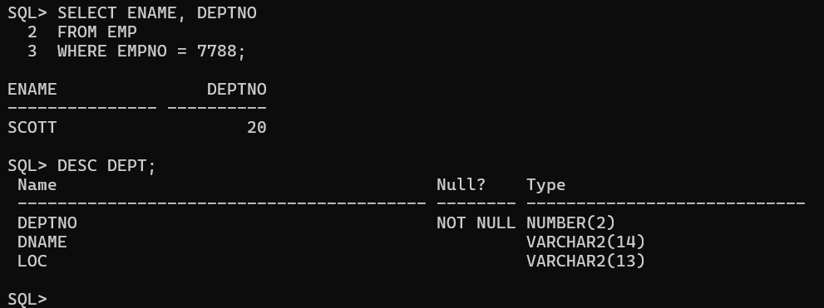

SELECT * FROM DEPT;
This displays all the contents (rows) of the DEPT table.
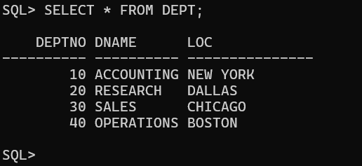

2 Determine the Structure of EMP Table and its Contents.

Sql : DESC EMP;
This shows the structure of the EMP table
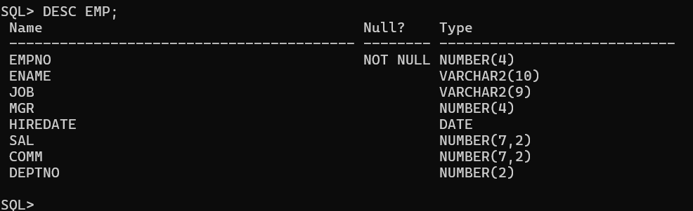

Sql : SELECT * FROM EMP;
This displays all the contents (rows) of the EMP table.
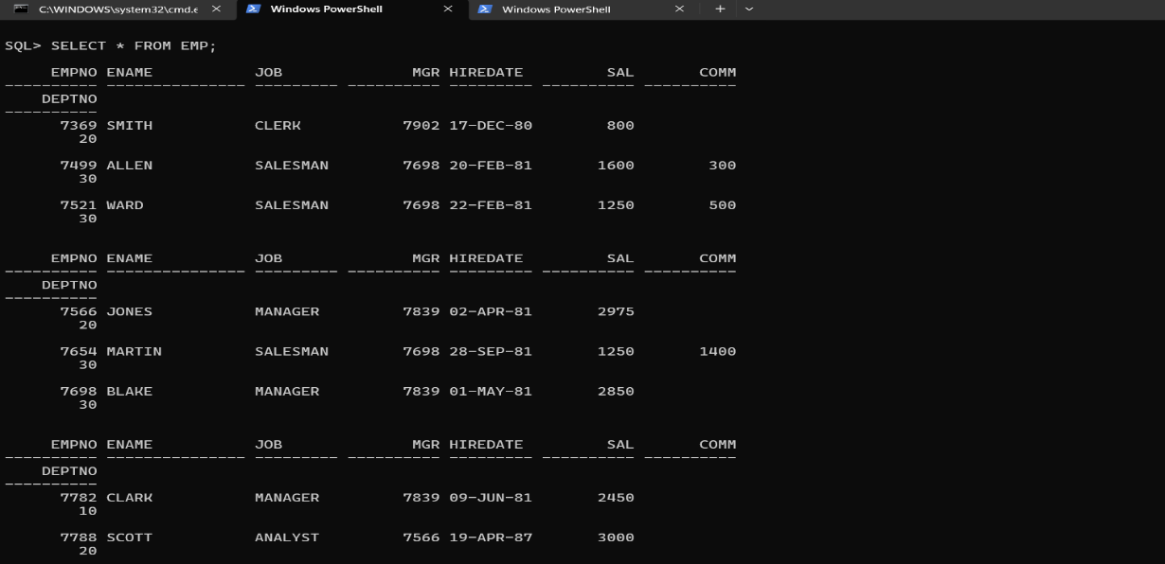
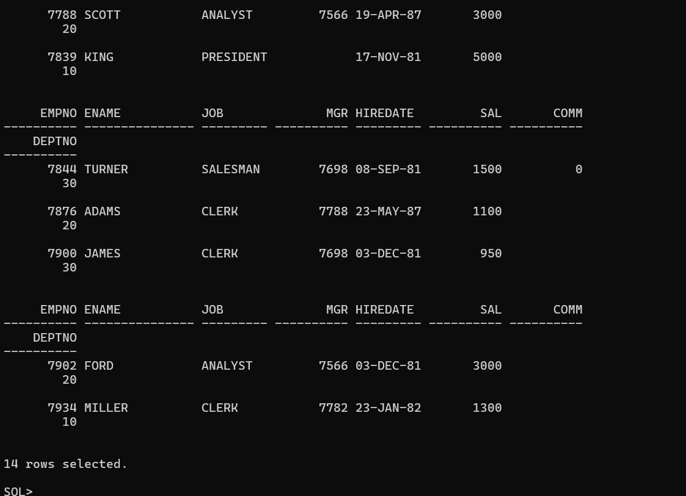
3. Display the Ename and Deptno from Emp table whose Empno is 7788.

Ans Here is to find the any data means retriving the data from data base.

Sql :
SELECT ENAME, DEPTNO
FROM EMP
WHERE EMPNO = 7788;
